LAB 7(1)
Aim:To assemble a NOR latch using two NOR gates from the 74HC02 chip with the R and S inputs connected to two Input Switches and the Q and Q’ outputs displayed on two LED Displays.
Components Used:
NOR gates
Slideswitch
Power supply(5,5)
Breadboard
Jumper wires
LEDs
Link of TinkerCad:
https://www.tinkercad.com/things/72LwIvRu3Xi-lab-7/editel?sharecode=468l9c2kyKcJsRZeCi5RX5n4IsSCSkErPZKvSP-Lwns
Pin Diagram:
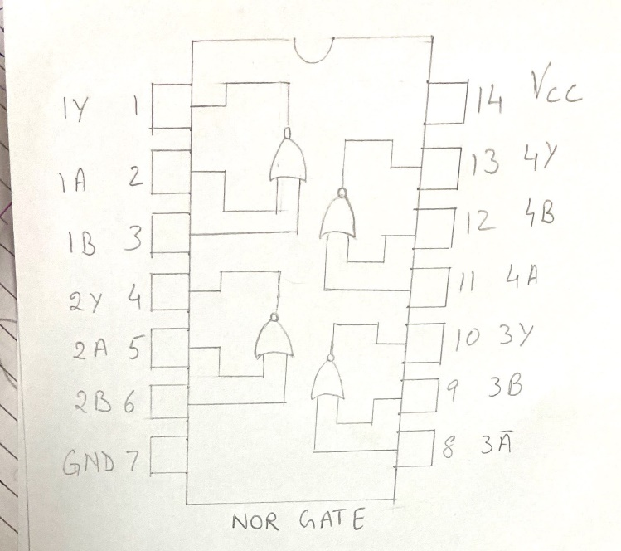

Circuit Diagram:
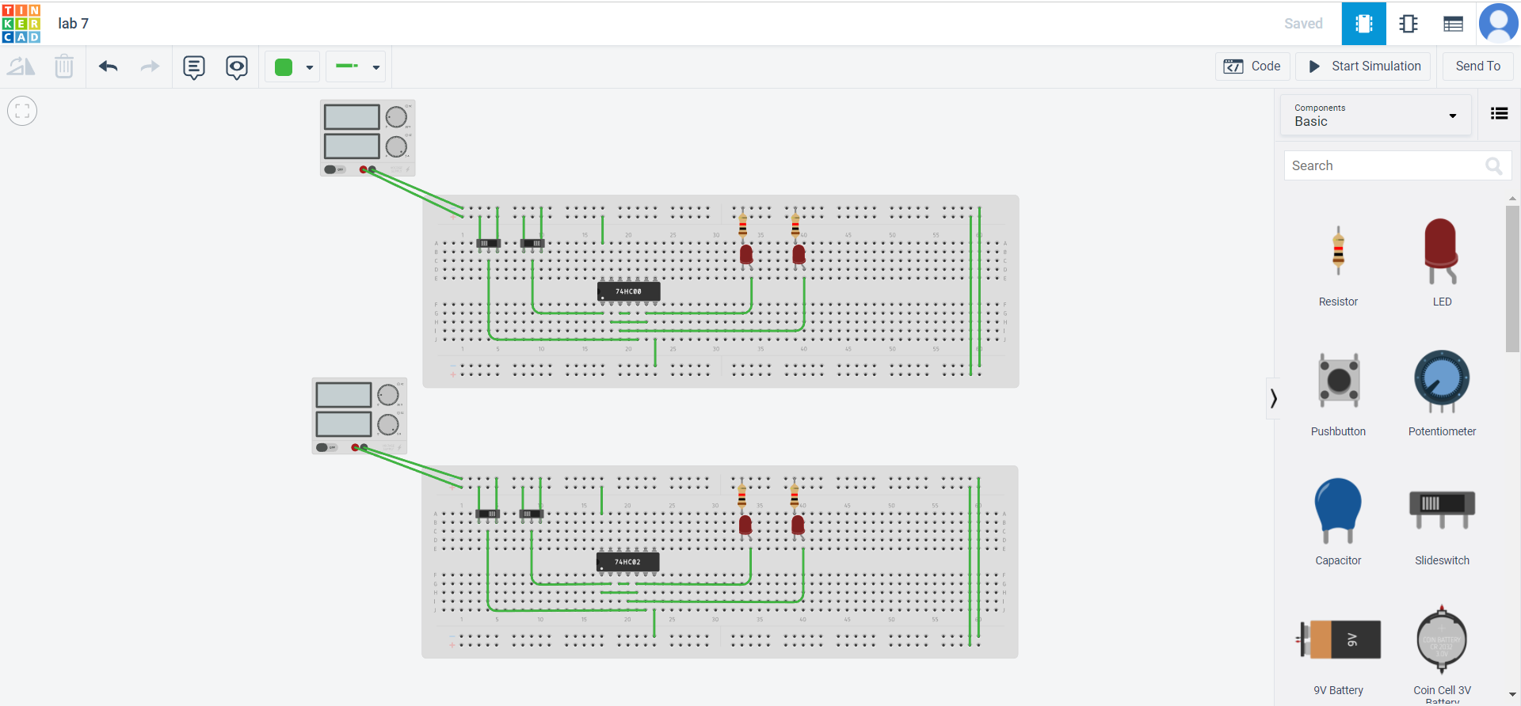
Characteristic Equation:
Q(n+1)=S+Q(n)R’
Characteristic Table:
Q | S | R | Q(n+1)
0 | 0 | 0 | 0
0 | 0 | 1 | 0
0 | 1 | 0 | 1
0 | 1 | 1 | X
1 | 0 | 0 | 1
1 | 0 | 1 | 0
1 | 1 | 0 | 1
1 | 1 | 1 | X

Excitation Table:
Q(n) | Q(n+1) | S | R
0 | 0 | 0 | X
0 | 1 | 1 | 0
1 | 0 | 0 | 1
1 | 1 | X | 0

Observation: The following table was observed for different input combinations.
S | R | Q | Q'
0 | 1 | 0 | 1
0 | 0 | 0 | 1
1 | 0 | 1 | 0
0 | 0 | 1 | 0
0 | 1 | 0 | 1
1 | 0 | 1 | 0
1 | 1 | 0 | 0
0 | 0 | 0 | 0
1 | 0 | 1 | 0
1 | 1 | 0 | 0
0 | 0 | 1 | 1

Results:The SR latch was implemented using nor gates.
Application:
Latch is a single bit storage element,they are used in power gating circuits and clocks as they can store element as memory.
Latches are also used as pulse latches, where they act as flip flops by pulsing the clock quickly.

LAB 7(2)
Aim:To assemble a NAND latch using two NAND gates from the 74HC02 chip with the R and S inputs connected to two Input Switches and the Q and Q’ outputs displayed on two LED Displays.
Components Used:
NAND gates
Slideswitch
Power supply(5,5)
Breadboard
Jumper wires
LEDs
Link of TinkerCad:
https://www.tinkercad.com/things/72LwIvRu3Xi-lab-7/editel?sharecode=468l9c2kyKcJsRZeCi5RX5n4IsSCSkErPZKvSP-Lwns
Pin Diagram:
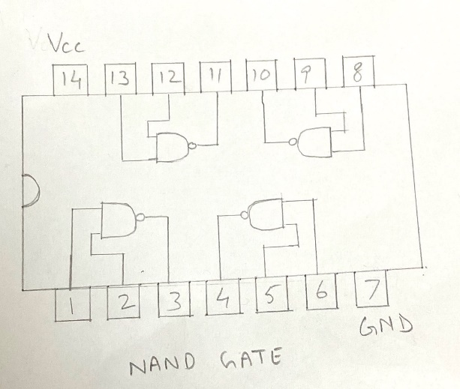

Circuit Diagram:

Characteristic Equation:
Q(n+1)=S’+Q(n)R
Characteristic Table:
Q | S | R | Q(n+1)
0 | 0 | 0 | 0
0 | 0 | 1 | 0
0 | 1 | 0 | 1
0 | 1 | 1 | X
1 | 0 | 0 | 1
1 | 0 | 1 | 0
1 | 1 | 0 | 1
1 | 1 | 1 | X

Excitation Table:
Q(n) | Q(n+1) | S’ | R’
0 | 0 | 0 | X
0 | 1 | 1 | 0
1 | 0 | 0 | 1
1 | 1 | X | 0

Observation:The following table was observed for different input combinations.
S | R | Q | Q'
1 | 0 | 0 | 1
1 | 1 | 0 | 1
0 | 1 | 1 | 0
1 | 1 | 1 | 0
1 | 0 | 0 | 1
0 | 1 | 1 | 0
0 | 0 | 1 | 1
0 | 1 | 1 | 0
0 | 0 | 1 | 1
1 | 1 | 1 | 1

Result:The NAND SR latch was successfully implemented.
Application:
Latch is a single bit storage element,they are used in power gating circuits and clocks as they can store element as memory.
Latches are also used as pulse latches, where they act as flip flops by pulsing the clock quickly.

